Psychology Cognitive Test on Developmental Psychology and Research Methods – Task 10 Overall Weighting of 6%

Aim: To consolidate knowledge gained by identifying areas of weakness concerning content.

SECTION A — Multiple Choice Questions
MULTIPLE CHOICE QUESTIONS
Instructions: Choose the response that is correct or that best answers the question.
Place your answer in the box provided. Only answers inside the boxes will be assessed.
A correct answer scores 1; an incorrect answer scores 0. Marks will not be deducted for incorrect answers.
No marks will be given if more than one answer is chosen for any question.

SECTION B — Short-Answer Questions
Research Methods

SECTION C — Short-Answer Questions

Developmental Psychology, Play and Personality

Space has been provided for each question. The expectation is that you should not need any more space to answer the question and should guide you for a length of response to achieve all possible marks.

Section A  Multiple Choice  11 | Section B  Research Methods  10 | Section C  Short Answer  42 | Total Score  64

SECTION A — Multiple Choice Questions
- An extraneous variable is best described as a/an ______ variable.

- participant
- experimenter
- dependent
- unwanted

- In an experiment, the group of participants used for comparison purposes in order to measure the effect of the experimental treatment is called a/an:

- control group
- dependent group
- experimental group
- independent group

- In an experiment, the variable that is manipulated or changed in some way by the experimenter is called the ______ variable, whereas the variable that is measured to find out the effects of the experimental treatment is called the ______ variable.

- Control; experimental
- Independent; dependent
- Experimental; control
- Dependent; independent

4. Two psychologists administer the same personality test to the same person on two separate occasions. The results are similar. This suggests that:

- the test is reliable.

- the test is valid.
- the individual's personality is simple.
- the individual's personality is complex.

- A psychologist interested in the effects of anxiety on exam performance asked research participants to describe how they feel during an exam when they come across a question they know they will get wrong. The participants’ responses were tape-recorded so that they could be analysed at a later time.

The type of data obtained by the researcher is best described as:
- descriptive data.

- quantitative data.
- qualitative data.
- statistical data.

- The period of the human lifespan that is marked by the beginning of puberty is known as:

A infancy.

B childhood.
C adolescence.
D middle age.

- CONTINUE TO THE NEXT PAGE -
- Which of the following age brackets best typifies middle age?

A 20–30
B 40–50
C 60–70
D 70+

- The story of a young girl named Genie who was locked in a confined space for most of her life shocked psychologists around the world. As a result of this abuse, Genie had great difficulty in mastering language and forming social relationships. This is due to the effect of:

A heredity factors.

B environmental factors.
C both heredity and environmental factors.
D neither heredity or environmental factors.

- Seven Up was a well-known television series that examined how the dreams and ambitions of individuals changed and developed every seven years. What sort of study was used in this series?

A A cross-sectional study.
B A self-report study.
C A snapshot study.
D A longitudinal study.

- Which of the following statements is most accurate about development?

A Motor, perceptual, cognitive and social development develop independently of one another.
B Motor and perceptual development are closely related, whereas cognitive and perceptual development are not.

C Motor, perceptual, cognitive and social development are related and affect one another.
D B and C are both correct.

- A child learns that a car is not the same as a bus. This is an example of

A accommodation

B assimilation
C centration
D egocentrism

TOTAL: 11 marks

SECTION B — Short-Answer Questions - Research Methods

Question 1
- A large body of evidence suggests that factors related to family relationships, such as conflict, communication and closeness are associated with a young person’s mental well-being. A psychology teacher, who is interested in the well-being of the students in his class, decides to look at this association amongst his students. He plans to ask his students to complete questionnaires about their family relationships and about their own emotional well-being.

A number of ethical issues arise from a study such as this. Identify two (2) important ethical issues that need to be considered.
[2 marks]
Description | 2 Marks
Gives a brief (one sentence) description of any two of the following:  Voluntary participation (teacher in position of authority) | 1
Confidentiality (student is telling teacher sensitive information about his/her family) | 1
Anonymity (teacher knows all the students and has to work with them in future) | 1
Informed consent (it would be important to get it, not just treat it like a lesson) | 1
Parental consent (it would be important to get it) | 1
Potential distress (if students are very upset or have a poor home life they may become distressed filling in the questionnaires) | 1

Describe the importance of one (1) ethical issue that could arise from the inclusion of refugee adolescents in the study described in Question 1(a). [2 marks]

Description | 1 Mark
Describes one factor clearly. Some possible factors would be:  - Refugee adolescents may not be able to read enough English to understand and complete the measures  - Refugee adolescents may not understand the same thing by ‘family’ as the Australian adolescent  - Refugee adolescents may express emotional problems differently from Australian adolescents  - The refugee students in the school or the teacher’s class may not be representative of the refugee population | 1
Question 2
This graph shows the average number of errors people made in Asch’s (1951) study.
Errors represent conformity to the incorrect responses of other group members.

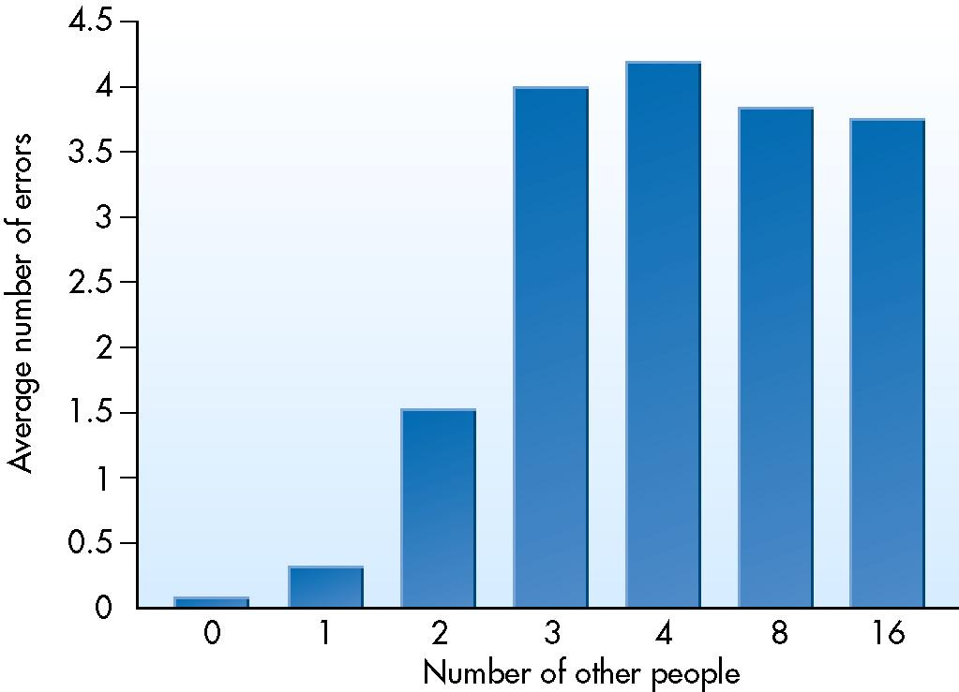

- State the dependent variable in this study. [1 mark]

number of errors
- What is the independent variable in this study? [1 mark]

group size

- What relationship between group size and conformity is demonstrated by this study?
[2 marks]

A larger group of people increases conformity; however, conformity plateaus after a group size of four.

Question 3
Make a statement for this graph including the direction and strength of this correlation.
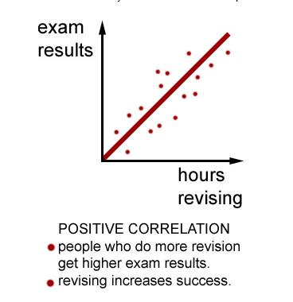

TOTAL: 10 marks

-Go to section 3-

SECTION C — Short-answer questions –Developmental Psychology - Answer all questions in the spaces provided.

Question 1
Describe the difference between Partin’s (1932) associative and cooperative ‘play’. (2 marks)

Associative play involves social interaction that has little organisation. The children seem interested in each other but there is little planning in the activities they undertake together

Cooperative Play involves children interacting in a group that has a sense of identity and purpose. Roles may be identified and rules may be set.

Question 2 (6 marks)

Smilanksy’s (1968) suggested that there are four (4) key areas of play development. Complete the following table summarizing her observations and theory.

Smilanksy’s (1968)  Stage of Play | Description of Play
Constructive Play | Use of objects or materials to make something
Dramatic Play | Pretend, imaginative fantasy play
Pretend Play | Largely imitative of adult caregiver and becomes more imaginative with age
Formal Games with Rules | Organised games with known procedures and penalties

Question 3 (1 mark)

Link the following understandings to a key area of development in regard to the impact of play
Social Readiness Physical Cognition

Understanding the ability to share in order to interact with others during playtime. | Social Readiness
Decision-making is important in developing skills. | Cognition
Practice and development of gross and fine motor skills | Physical

Question 4 (2 marks)

Describe the ‘principle of readiness’.

The principle of readiness states that unless the necessary bolidly structures, be they muscles, bones or nerves, are sufficiently developed, then no amount of maturity? will produce the particular behaviour. It is only when an individual is maturationally** ready that development of these behaviours will occur.

Question 5 (4 marks) With reference to diagrams A and B:
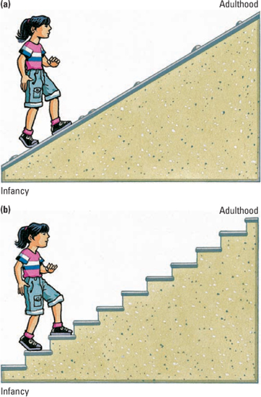
In what way do these views of lifespan development differ?
Continuous development involves gradual and ongoing changes throughout the lifespan without sudden shifts, with abilities in the earlier stages of development providing the basis of skills and abilities required for the next stages.
Discontinuous development involves distinct and separate stages, with different kinds of abilities occurring in each stage. The development of certain abilities in each stage, such as specific ways of thinking, feeling or socially interacting have identifiable start and end points

Question 6 (4 marks)
Name the six lifespan development stages and the approximate age ranges associated with each stage.
- infancy: birth to 2 years
- childhood: 2 – 10 years
- adolescence: 10 - 20 years
- early adulthood: 20 - 40 years
- middle age: 40 - 65 years
- older age: 65 years and beyond

Award 2 marks for correctly identifying all six stages and 2 marks for their associated age ranges or 1 mark for correctly identifying at least three stages and associated age ranges.

Question 7 (2 marks)

Try to explain the effect of physical development on ‘Body Image’ in males and females.

Early maturing girls are more likely to be involved with sexual activity, drugs and alcohol than late maturing girls. Early maturing girls have also demonstrated greater levels of parental conflict and lower grades at school, despite having the same intelligence as later maturing girls.

Late maturing boys are more likely to become flexible, assertive and insightful in later life, whereas early maturing boys tend to be more confident and popular in school.
Question 8 (2 marks)
Explain Bandura’s later version of his Social Learning Theory

Albert Bandura revised his original observational learning theory using the bobo doll; from a person watching behaviour and copying the behaviour, to people having the ability to choose who they wish to copy. Learners will copy those people who are important to them and behaviours that match their beliefs and values (Children will copy idols, family and peers as these are important figures to them). Children would not copy behaviours that did not follow their own values.

Question 9 (4 marks)

There are many different kinds of developmental change that occur throughout the human lifespan. Generally, developmental psychologists classify changes, which take place in terms of four main domains: physical, social, cognitive and emotional. Describe two of these domains.

Cognitive | Involves changes in an individual’s mental abilities (1) such as perception, thinking, learning, memory, language, moral reasoning, problem solving and decision making (1)
Physical | Involves changes in the body and its various systems (1) such as development of the brain and nervous system, bones and muscles, motor skills (movement), and the hormonal changes of puberty and menopause (1)
Social | Changes in an individual’s relationships with other people and their skills in interacting with others (1), such as the ability to form close relationship and interact with other in a group situation (1)
Emotional | Changes in how an individual experiences different feelings (1) and how these feelings are expressed, interpreted and dealt with (1)

Question 10 (2 marks)
How do twin studies support the nature/nurture debate?
Identical twins are formed by one egg and one sperm splitting, therefore they have 100% identical DNA. (1) Fraternal twins are from two eggs and two sperm, so have similar DNA to normal siblings. Identical twins that are reared apart show that any differences are from environmental factors (nurture). (1)

Question 11 (4 marks)

How do adoption studies support the nature/nurture debate? Explain two (2) ethical issues that a psychologist would have to consider when conducting this type of research.

Adoptions studies: if the adoptive child is similar to adoptive parent this supports Nurture, where as if they are similar to their biological parent this supports nature. (2)

Ethical Issue one (1mark)
Ethical Issue two (1 mark)

Question 12 (2 marks)

What is the difference between accommodation and assimilation?
Assimilation is the taking in new information and relating it to schemas that already exist
Accommodation is taking in new information and changing existing schemas that already exist

Question 13 (1 mark)

What does cognitive development refer to?
Changes in abilities such as thinking and reasoning, memory, attention, imagination and language

Question 14 (6 marks)
Complete the following table detailing Piaget’s Cognitive stages of development.

Name of Stage | Age | Key Feature
Sensori-motor | Birth – 2 years | views the world though its senses and motor abilities (touch, sight)
Pre-Operational | 2-7 | Egocentric
Concrete Operational | 7-11 | think logically and classify items into groups.
Formal Operational | 11- 15 | Think hypothetically
*1 mark only for the age range and the 1 mark per box

TOTAL: 42 marks

